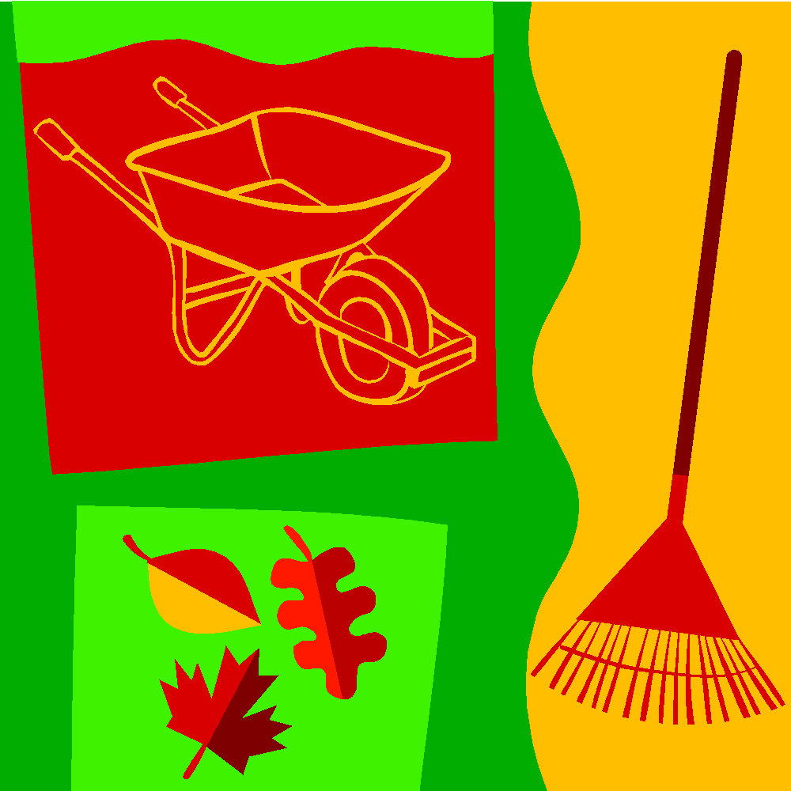

FALL MULCH SALE
MOUNT VERNON HIGH SCHOOL
Proceeds go to the MVHS Prom

Sale & Delivery: Saturday, Oct 20th, 2018

Pick-up orders in the Mount Vernon High School parking lot from 7am-2pm. Orders of 10 bags or more will be delivered to your home for selected zip codes (22308 & 22309).

$6.00/bag – 3 cubic feet, double shredded hard bark mulch
If you have a lawn service, order from us and have them spread it.
For more information contact: Ms. Mary Lawson mclawson@fcps.edu
Ms. Dominique Thomas dethomas1@fcps.edu
Your order and payment must be received no later than
October 5th, 2018

Please mail your check and order to: Mount Vernon High School
Fall Mulch Sale/Class of 2020
8515 Old Mount Vernon Road
Alexandria, VA 22309

Mulch Sale Order Form

Name: ___________________________________ Phone #: _________________________

Address: _____________________________________________________________________

Subdivision: _____________________________ Email: _____________________________

Delivery instructions (e.g., next to garage): ____________________________________________

Number of bags: _______ @ $6.00/bag = Total due: $ ___________

I do not need any mulch, but am enclosing a tax-deductible contribution in the amount of $__________.

Please make checks payable to: MVHS
Note “Fall Mulch Sale, Juniors, or Class of 2020”
Thank you for your support!

