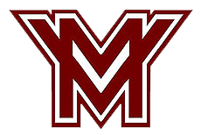

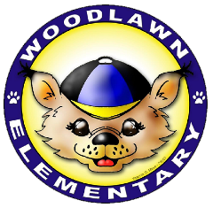
Mount Vernon Pyramid
Back to School
Resource Fair
Date: August 14, 2018
Time: 2:00-6:00 p.m.
Location: Mount Vernon High School
8515 Old Mt. Vernon Rd
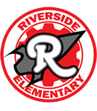
Alexandria, VA 22309
Free basic school supplies for students in need
Free health screenings for children
Information about getting involved at your child’s school
Help registering for a parent account to track academic progress and important student information
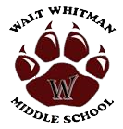
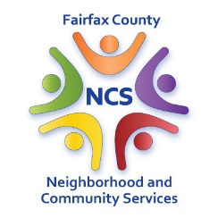
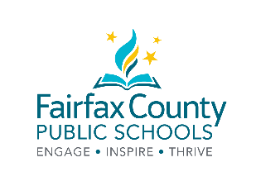
Representatives from community organizations, FCPS offices and Fairfax County programs offering information and assistance for families.

