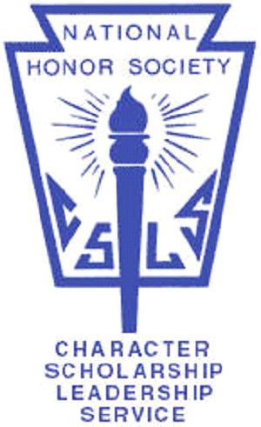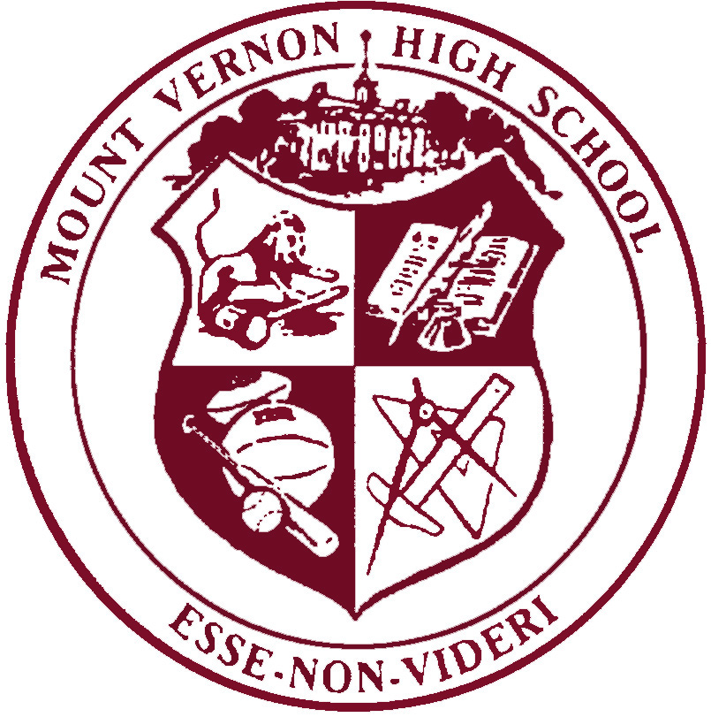
Information about applying to be a
member of the
National Honor Society

The National Honor Society at MVHS is accepting applications until October 4, 2019. Students must have completed their freshman year, have a minimum cumulative grade point average of 3.5 and must have demonstrated a commitment to service and scholarship.

To apply for acceptance into the NHS, students must:
- Complete the NHS Application form on link below.
- Write a reflective essay to the prompt found on the document, on the link below
- Obtain recommendations from two current or former teachers.

Applicants will have their packets reviewed by a council of MVHS faculty and applicants will be notified about acceptance by October 25, 2019.

For more information about the National Honor Society, visit the website, http://www.nhs.us

Application:
https://goo.gl/forms/QD4bhE98G0wObwWg1

Rubric and prompt: Recommendation:
https://goo.gl/mNMXeR https://goo.gl/forms/kr7etIjTZ6rekf5v2

